TASK 3

1. Data Understanding & Preprocessing

1.1 Dataset Overview
The dataset used in this project contains employee records with demographic, professional, and workplace-related attributes. The target variable is Attrition, indicating whether an employee Stayed or Left the organization.

Property | Details
Training Set Size | 59,598 rows x 24 columns
Test Set Size | 14,900 rows x 24 columns
Target Variable | Attrition (Stayed / Left)
Missing Values | None (all columns complete)
Features after Encoding | 41 features (after get_dummies)

1.2 Key Features
The dataset includes the following feature categories:
- Demographic: Age, Gender, Marital Status, Number of Dependents
- Professional: Job Role, Job Level, Education Level, Years at Company
- Compensation: Monthly Income, Number of Promotions
- Workplace: Work-Life Balance, Job Satisfaction, Performance Rating, Overtime
- Organizational: Company Size, Company Tenure, Remote Work, Company Reputation
- Target: Attrition (Stayed = 0, Left = 1)

1.3 Class Distribution
The target variable is fairly balanced, with 31,260 employees who Stayed and 28,338 who Left, making it suitable for binary classification.

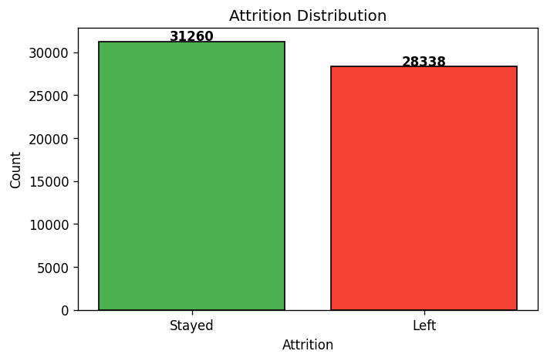

1.4 Handling Missing Values & Encoding
Upon inspection, the dataset had no missing values across all 24 columns. The Employee ID column was dropped as it carries no predictive signal. The target column Attrition was label-encoded (Stayed = 0, Left = 1). All remaining categorical features were one-hot encoded using pandas get_dummies with drop_first=True to avoid multicollinearity, resulting in 41 input features.

1.5 Numeric Feature Distributions
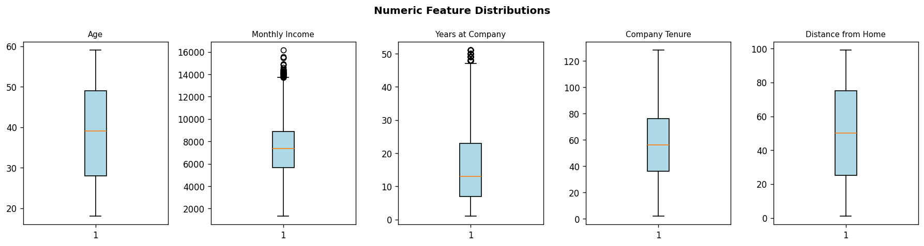
Age ranges from 18 to around 65, Monthly Income from ~1,300 to ~13,000, and Company Tenure spans a wide range. No extreme outliers were observed that would require removal.

2. Exploratory Data Analysis (EDA)

2.1 Correlation Heatmap
A correlation heatmap was plotted for all numeric features. Distance from Home shows a slight positive correlation with Attrition (0.096), while Number of Promotions and Years at Company show negative correlations, meaning more tenured and promoted employees tend to stay.

2.2 Feature Importance Insights
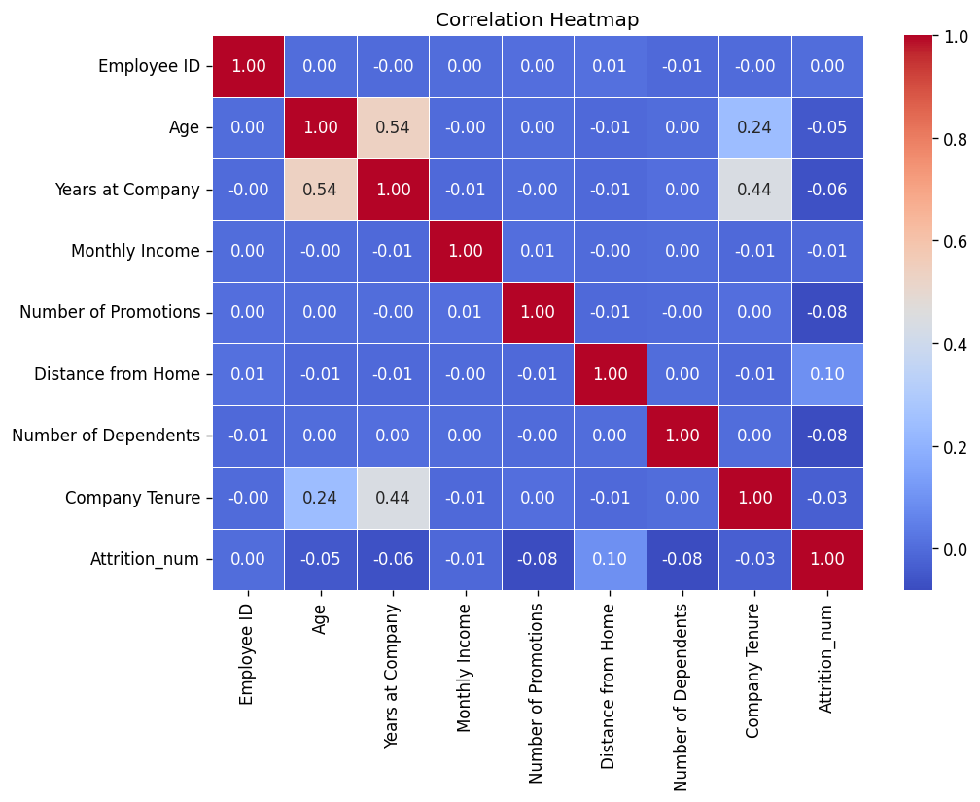
Using XGBoost feature importances, the top predictors of attrition were identified. Marital Status (Single), Job Level (Senior), Remote Work, and Work-Life Balance (Poor) were the strongest signals.
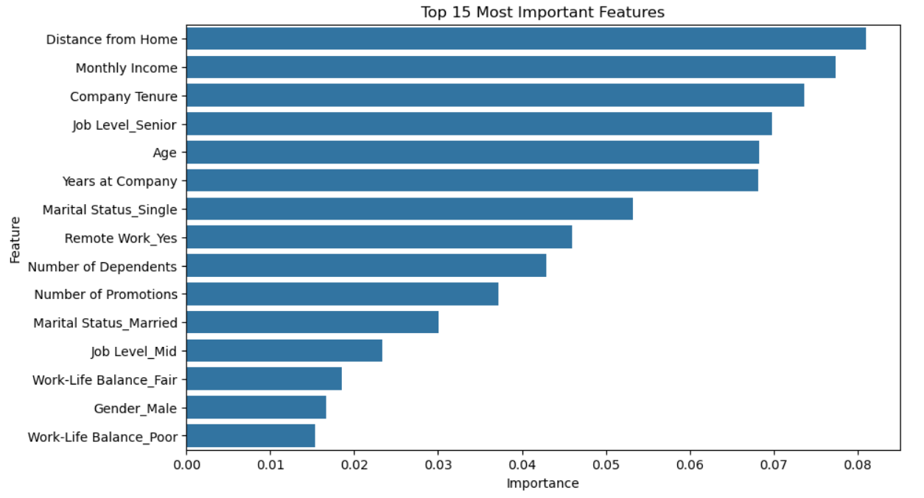

3. Model Implementation
Five machine learning algorithms were implemented using scikit-learn. Data was split 80/20 for training and validation using stratified sampling to preserve the class ratio. StandardScaler was applied for distance-based models (Logistic Regression and KNN).

3.1 Models Trained
- Logistic Regression - Linear model using sigmoid function, trained on scaled features
- Decision Tree - Tree-based model with recursive binary splits, no scaling needed
- Random Forest - Ensemble of 200 decision trees, averaging predictions
- K-Nearest Neighbors (KNN) - Predicts based on majority class among 5 nearest neighbors
- XGBoost - Gradient-boosted ensemble with 200 trees, max_depth=6, learning_rate=0.1

4. Model Evaluation & Comparison

4.1 Metrics Summary
All models were evaluated on the validation set (11,920 samples) using Accuracy, Precision, Recall, and F1-Score.

Model | Accuracy | Precision | Recall | F1 Score
XGBoost | 75.05% | 73.81% | 73.68% | 73.74%
Logistic Regression | 74.78% | 73.73% | 72.95% | 73.34%
Random Forest | 74.60% | 73.79% | 72.23% | 73.00%
ANN | 74.85% | 72.64% | 75.56% | 74.07%
KNN | 66.95% | 64.69% | 67.13% | 65.89%
Decision Tree | 66.17% | 64.35% | 64.68% | 64.51%

4.2 Visual Comparison

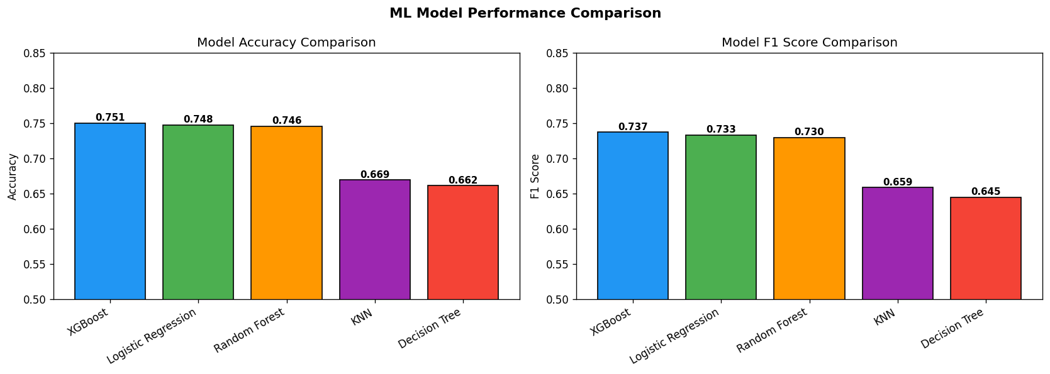

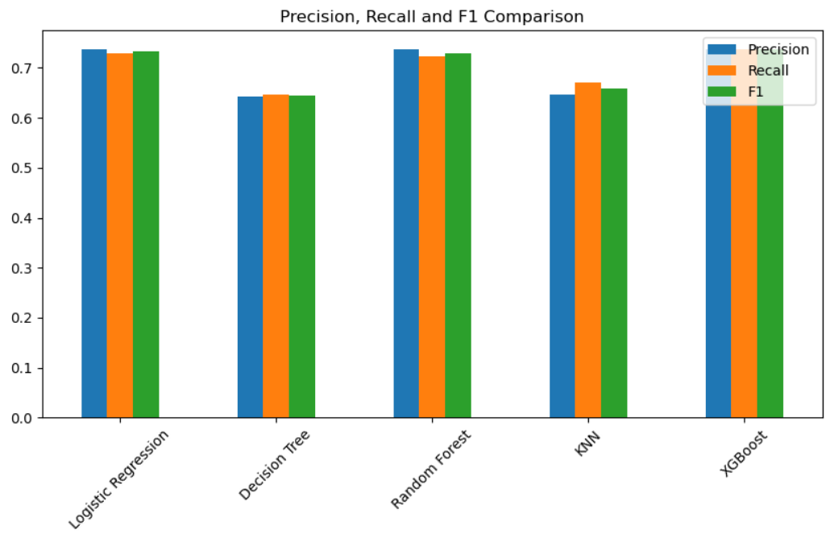

4.3 Confusion Matrices
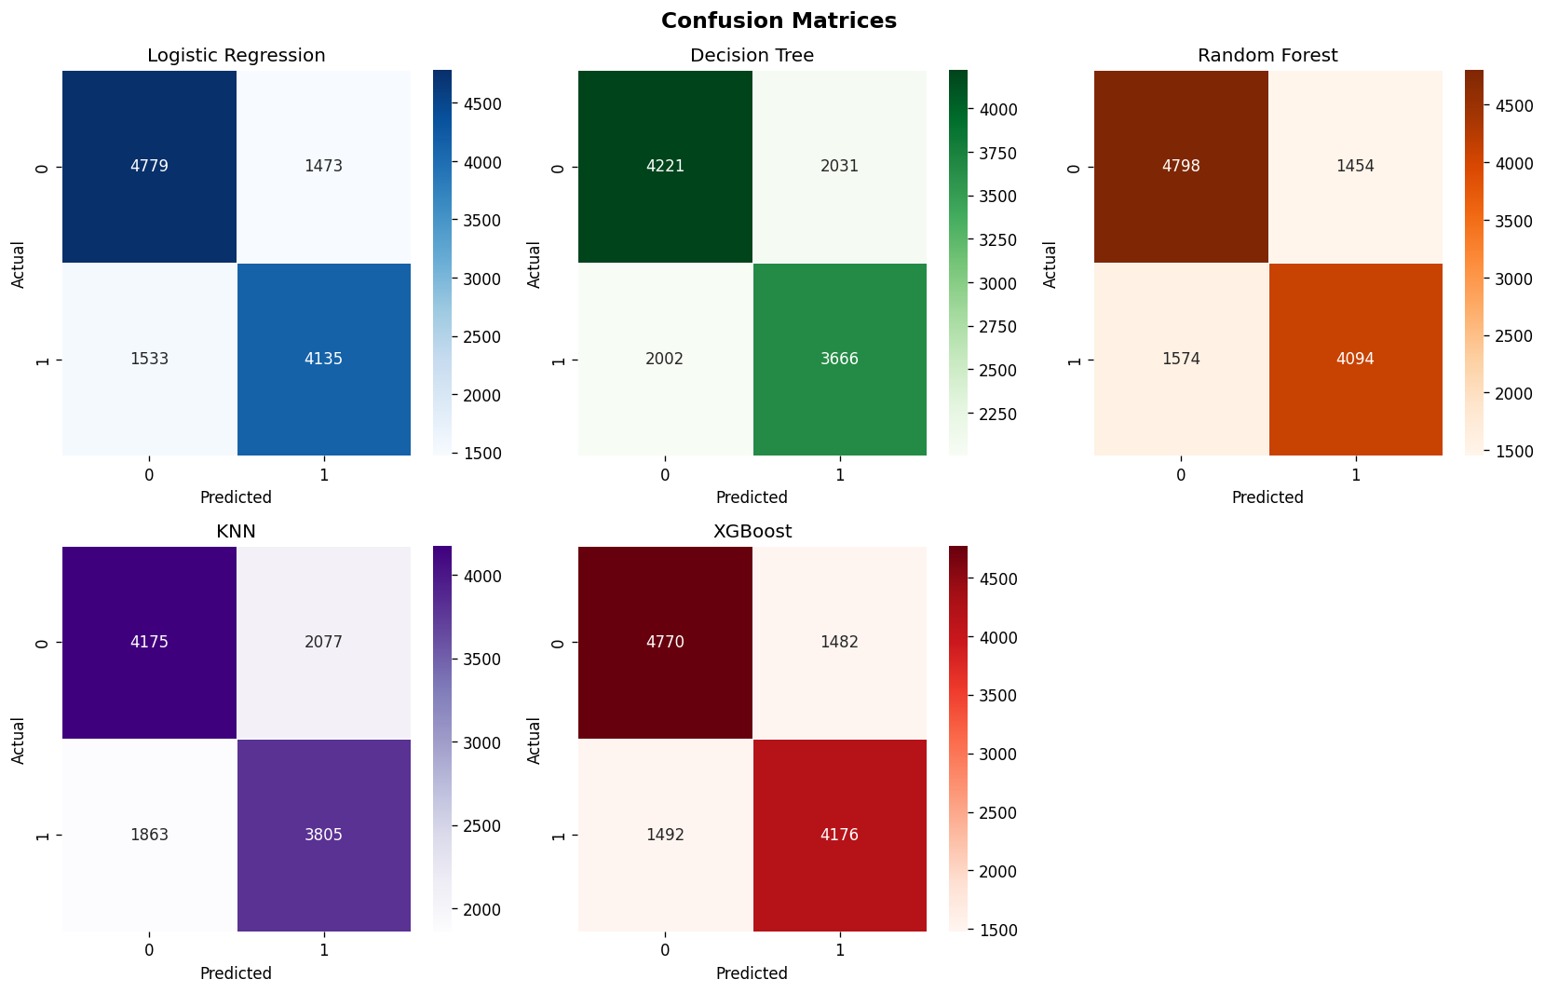
4.4 Analysis & Interpretation
XGBoost performed best with 75.05% accuracy and 73.74% F1 score. It benefits from gradient boosting's ability to correct errors iteratively and handles feature interactions well. Logistic Regression came in a close second at 74.78%, showing that the classes are somewhat linearly separable. Random Forest achieved similar accuracy (74.60%), confirming that ensemble methods outperform single trees.

KNN and Decision Tree underperformed compared to ensemble methods. KNN is sensitive to irrelevant features and high dimensionality (41 features after encoding), which reduces its effectiveness. The Decision Tree likely overfit slightly, giving lower generalization.

The fairly balanced accuracy across models (~75%) suggests the dataset has moderate predictive signal. The lack of very high accuracy could be due to subjective features (like Job Satisfaction) where employee behavior is inherently hard to predict purely from structured data.

4.5 Error Analysis
XGBoost misclassified 2,974 out of 11,920 validation samples. False negatives (employees predicted to stay but actually left) are more concerning in HR applications, as they represent at-risk employees who go unidentified. The confusion matrices show a fairly balanced error distribution between both classes, suggesting no strong systematic bias.

5. From-Scratch Implementation
Two algorithms were implemented from scratch using only NumPy, without any scikit-learn: K-Nearest Neighbors (KNN) and Logistic Regression.

5.1 KNN from Scratch
The scratch KNN implementation manually computes Euclidean distance between the test point and all training points, selects the k=5 nearest neighbors, and predicts by majority vote. The mathematical formula used:
d(x, x') = sqrt( sum( (xi - xi')^2 ) )

5.2 Logistic Regression from Scratch
The scratch Logistic Regression uses gradient descent to minimize binary cross-entropy loss. The sigmoid function converts linear output to a probability. The update rule applied at each step:
sigmoid(z) = 1 / (1 + e^-z) | w = w - lr * X^T * (y_hat - y)
The model was trained for 1000 epochs with a learning rate of 0.01.

5.3 Library vs Scratch Comparison
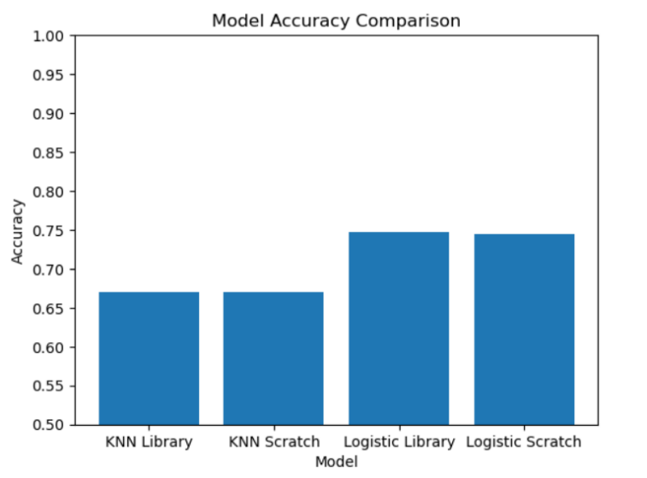

Model | Accuracy
KNN Library | 66.95%
KNN Scratch | 66.95%
Logistic Regression Library | 74.78%
Logistic Regression Scratch | 74.50%

The KNN scratch implementation matched the library version exactly (66.95%), validating the correctness of the implementation. The Logistic Regression scratch version achieved 74.50% vs 74.78% for the library - a minimal gap of ~0.3%. This difference is expected due to different optimization strategies (scikit-learn uses L-BFGS solver vs. basic gradient descent in scratch) and default regularization in the library version.

6. Artificial Neural Network (ANN)

6.1 Architecture
A Feedforward Multilayer Perceptron (MLP) was built using TensorFlow/Keras. The network architecture is:
- Input Layer: 41 features
- Dense Layer 1: 128 neurons, ReLU activation
- Dropout: 30% (for regularization)
- Dense Layer 2: 64 neurons, ReLU activation
- Dropout: 30%
- Dense Layer 3: 32 neurons, ReLU activation
- Output Layer: 1 neuron, Sigmoid activation

The model was compiled with Adam optimizer, binary cross-entropy loss, and trained for 20 epochs with batch size 32. Total trainable parameters: ~13,505.

6.2 Training Results
The ANN converged quickly, reaching ~74.8% validation accuracy from the first epoch. Training and validation accuracy moved in sync, showing no overfitting.
ANN Results: Accuracy = 74.85%, Precision = 72.64%, Recall = 75.56%, F1 = 74.07%

6.3 ANN vs Traditional ML Models
Comparing ANN with the best traditional ML model (XGBoost):
- ANN has the highest Recall (75.56%) among all models - it identifies the most actual leavers
- XGBoost has marginally better accuracy (75.05% vs 74.85%)
- ANN shows better generalization than single-model approaches
- XGBoost remains more interpretable and faster to train

The ANN's higher recall is particularly valuable for HR use cases - it minimizes employees who are about to leave being misclassified as staying. For an attrition prediction task, recall is often more important than precision, making the ANN a practical choice.

6.4 Questions on ANN
1. What Artificial Neural Networks Are and the Inspiration Behind Them
Artificial Neural Networks (ANNs) are computational models inspired by the structure and functioning of the human brain. Just as biological neurons communicate through electrical signals, artificial neurons process information and pass it to other neurons in a network. ANNs are designed to learn patterns from data, enabling them to perform tasks such as classification, regression, image recognition, and prediction.
The primary inspiration behind ANNs comes from the interconnected network of neurons in the human nervous system..

2. How Neurons Process and Transmit Information
An artificial neuron receives multiple input values, each associated with a weight.
The neuron performs the following operations:
Multiply each input by its corresponding weight.
Sum all weighted inputs.
Add a bias term.
Apply an activation function.
Produce an output that is passed to the next layer.
Mathematically:
$$z=\sum_{i=1}^{n}{w_{i}}x_{i}+b$$

3. Forward Propagation and Data Flow Through the Network
Forward propagation is the process by which data moves through the neural network.
The flow is:
Input Layer → Hidden Layer(s) → Output Layer
Steps:
Input features are fed into the network.
Hidden layers perform computations using weights and activation functions.
Information is propagated layer by layer.
The final layer produces the prediction.
For example, in a classification problem:
Inputs: Age, Income, Education
Hidden Layers: Learn complex feature interactions
Output Layer: Predicts class label
Forward propagation transforms raw input data into meaningful predictions.

4. Activation Functions and Their Importance
Activation functions introduce non-linearity into neural networks. Without them, a deep neural network would behave like a simple linear model regardless of its depth.
Common activation functions include:
ReLU (Rectified Linear Unit)
$$f(x)=max⁡(0,x)$$
Advantages:
Computationally efficient
Reduces vanishing gradient problems
Most widely used in hidden layers
Sigmoid
Maps outputs between 0 and 1, making it useful for binary classification.
Softmax
Converts outputs into probabilities that sum to 1, commonly used in multi-class classification.
Activation functions enable ANNs to learn complex and non-linear relationships within data.

5. Backpropagation and the Intuition Behind Learning from Errors
Backpropagation is the learning mechanism of neural networks.
The process works as follows:
The network makes a prediction.
The prediction is compared with the actual value using a loss function.
The error is calculated.
The error is propagated backward through the network.
Weights are adjusted to reduce future errors.
This adjustment is typically performed using Gradient Descent.
Intuitively, backpropagation is similar to learning from mistakes. If the prediction is incorrect, the network identifies which weights contributed most to the error and updates them accordingly.
Over many iterations, the network gradually improves its predictions and learns meaningful patterns from the data.

6. Why ANNs Are Powerful Despite Simple Building Blocks
Each artificial neuron performs only a simple mathematical operation. However, when thousands or millions of neurons are connected together, they can model highly complex relationships.
Key reasons for their power include:
Ability to learn non-linear patterns
Automatic feature extraction
Scalability to large datasets
Capability to handle high-dimensional data
Universal approximation capability
This combination allows ANNs to achieve state-of-the-art performance in areas such as image recognition, speech processing, natural language understanding, and recommendation systems.

6.5 Analysis
When Did the ANN Outperform Traditional Models, and Why?
The ANN outperformed traditional machine learning models when the dataset contained complex and non-linear relationships between features. Multiple hidden layers allowed the network to learn intricate patterns that models such as Logistic Regression could not capture effectively.

Where Did Traditional Models Perform Competitively?
Traditional models performed competitively when:
The dataset was relatively small.
Relationships between features and target variables were mostly linear.
Noise levels were low.
Features were already well-engineered.
For example, Logistic Regression often achieves results close to ANN performance on structured tabular datasets while requiring significantly less training time and computational resources.

What Data-Related or Structural Factors Influenced These Outcomes?
Several factors influenced model performance:
Dataset Size
ANNs generally benefit from larger datasets because they contain many trainable parameters. With limited data, they may overfit.
Feature Complexity
Datasets with highly non-linear relationships favor ANNs because hidden layers can model complex interactions.
Feature Engineering
Traditional models depend heavily on engineered features, whereas ANNs can automatically discover useful feature representations.
Network Architecture
The number of hidden layers, neurons, activation functions, and regularization techniques directly affect ANN performance.
Data Quality
Missing values, noise, and class imbalance can impact both ANN and traditional models, although ANNs are often more sensitive to poor-quality data.

7. Conclusion
This project successfully implemented a complete machine learning pipeline for employee attrition prediction on a dataset of ~74,000 records. Key findings:
- XGBoost achieved the best overall accuracy (75.05%) and F1 Score (73.74%)
- Logistic Regression and Random Forest performed comparably, suggesting moderate linear separability
- KNN and Decision Tree underperformed on this high-dimensional dataset
- ANN achieved the highest Recall (75.56%), making it the best choice for identifying at-risk employees
- From-scratch KNN exactly matched the library, and scratch Logistic Regression came within 0.3%
- Marital Status (Single), Job Level (Senior), and Remote Work were the top attrition predictors

BY SNEHAL MUDULI

